|  |  |  |  |
| --- | --- | --- | --- |
| **Lyng Primary School Knowledge Organiser**  **Geography** | | | |
| **Topic: Geography** | **All about me and the Great Fire of London**  **What is it like here?** | Year 1 | Autumn |

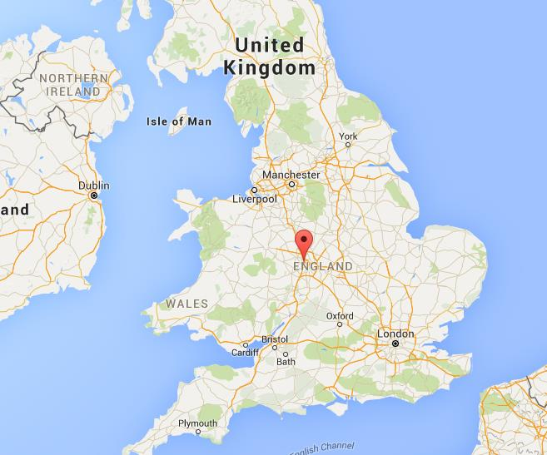

**Background information for parents and teachers**

London is the capital city of England, which is a country in the United Kingdom. It's located in the southeastern part of England. London has famous landmarks like the Tower of London, Buckingham Palace (where the King lives) and Big Ben. People get around London using different types of transportation like buses, trains (called the Underground or Tube), and black taxis.

West Bromwich is a town in the West Midlands region of England. It's not far from the city of Birmingham. There are parks and green areas in West Bromwich, including Sandwell valley. In West Bromwich, there are houses where families live. Some houses are close together, and some are farther apart. There are also buildings like schools, shops, and churches. The local landmarks in West Bromwich include the library, Dartmouth Park and All Saints Church.

|  |  |
| --- | --- |
| **What Step On and Goldilocks words will I use?** | |
| **Spelling** | **Definition** |
| Community | The community is all the people who live in a particular area or place. |
| Landmarks | A landmark is a building or feature which is easily noticed and can be used to judge your position or the position of other buildings or features. |
| Countries | A country is one of the political units which the world is divided into, covering a particular area of land. |
| local | Local means existing in or belonging to the area where you live, or to the area that you are talking about. |
| location | A location is the place where something happens or is situated. |
| diversity | The diversity of something is the fact that it contains many very different elements. |
| multicultural | Multiculturalism is a situation in which all the different cultural or racial groups in a society have equal rights and opportunities, and none is ignored or regarded as unimportant. |
| culture | Culture consists of activities such as the arts and philosophy, which are considered to be important for the development of civilization and of people's minds. |

|  |
| --- |
| **Geographical study** |
| * Looking at local geography around Lyng Primary school and label locations. We will walk around our school ground and label the carpark, forest, playground and field. * Children will look in depth at their family. They will explore where their family come from and where they now live. They will compare and contrast the 2 locations. * Find and locate local landmarks and famous landmarks in London using maps. * Find and label the countries in the UK. * Find and label the capital cities in the UK. * Compare London to West Bromwich |

**Fieldwork Opportunities**

Walk around the school.

Walk around the local community.

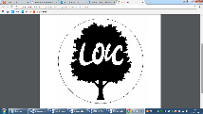

**Significant places**

* UK
* London
* West Bromwich

**Our Storytelling Approach to enhance engagement**

|  |  |  |
| --- | --- | --- |
| **People:**  YEAR 1  All of the children are special people we will study. | **Place:**  West Bromwich  Places family or friends are from  London | **Problem:**  How did we get here? |

**Map to be studied**

**Facts and Locations**

Google maps. West Bromwich

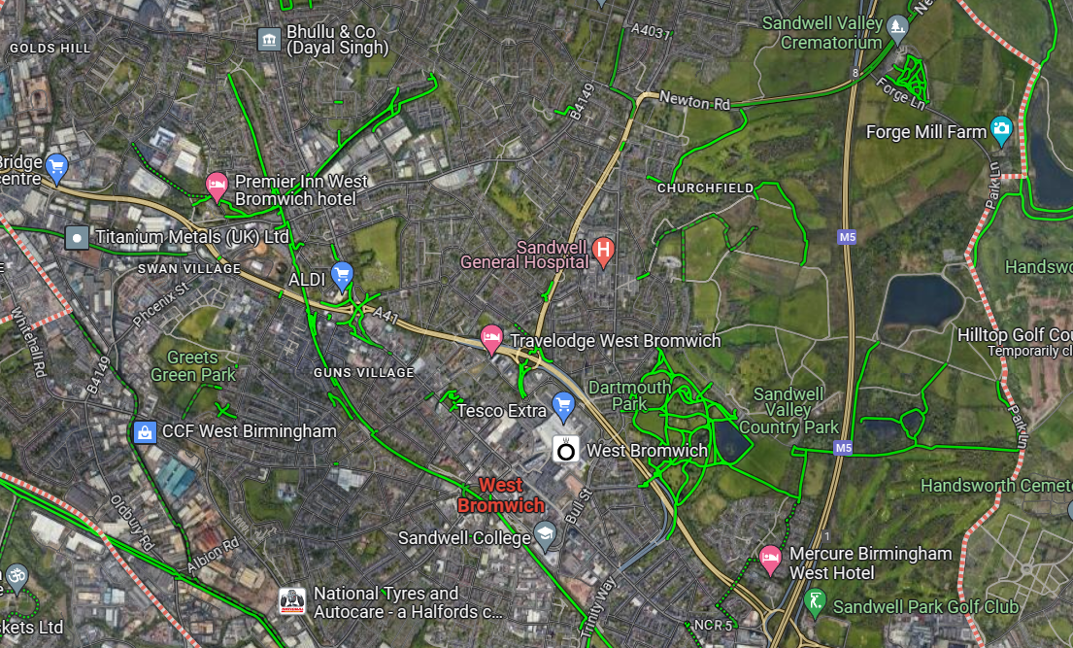

London

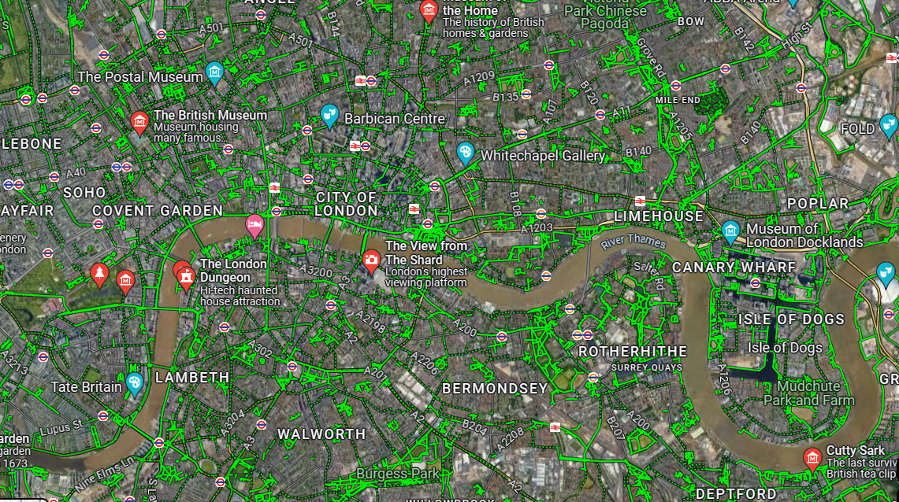

**London**

London is the capital city of England

It's in the southeastern part of England.

London has famous landmarks like the Tower of London, Buckingham Palace and Big Ben.

People get around London using buses, trains (called the Underground or Tube), and black taxis.

**West Bromwich**

West Bromwich is a town in the West Midlands region of England.

There are parks and green areas in West Bromwich, including Sandwell Valley.

In West Bromwich, there are houses where families live (detached houses, semi-detached houses, terrace houses and flats.

The local landmarks in West Bromwich include the library, Dartmouth Park and All Saints Church.

There are 4 countries in the United Kingdom, England, Scotland, Wales and Northern Ireland. England’s capital is London, Wales’ capital is Cardiff, Scotland’s capital is Edinburgh and Northern Ireland’s is Belfast.

**Key questions**

**Agreed Outcome**

Lets say… Build our town.

Where do you live?

What landmarks are in London and West Bromwich?

What 4 countries are in the United Kingdom?

What are the capital cities in England, Wales, Scotland and Northern Ireland?

|  |  |  |  |
| --- | --- | --- | --- |
| **Lyng Primary School Knowledge Organiser** | | | |
| **Topic: Geography** | **What is it like here?** | Year 1 | Autumn |

|  |  |  |
| --- | --- | --- |
| 1. What is the capital city of England? | **S** | **E** |
| Sydney |  |  |
| Cardiff |  |  |
| London |  |  |

|  |  |  |
| --- | --- | --- |
| 1. Where is Lyng Primary school? | **S** | **E** |
| Birmingham |  |  |
| London |  |  |
| West Bromwich |  |  |

|  |  |  |
| --- | --- | --- |
| 1. Draw a picture of an area around our school. |  |  |
| **S** | | |
| **E** | | |

**West Bromwich and London**

**Quick Quiz**

|  |  |  |
| --- | --- | --- |
| 1. Which is not a landmark in London? | **S** | **E** |
| Eiffel tower |  |  |
| London Bridge |  |  |
| Big Ben |  |  |

|  |  |  |
| --- | --- | --- |
| 1. What does diversity mean? | **S** | **E** |
| All the same |  |  |
| People are from different places with different cultures. |
| Dance club |

|  |  |  |
| --- | --- | --- |
| 1. What are the 4 countries in the United Kingdom? | **S** | **E** |
| **S** | | |
| **E** | | |